**Create Container Programmatically in Windows Azure**

Step 1: Create storage.

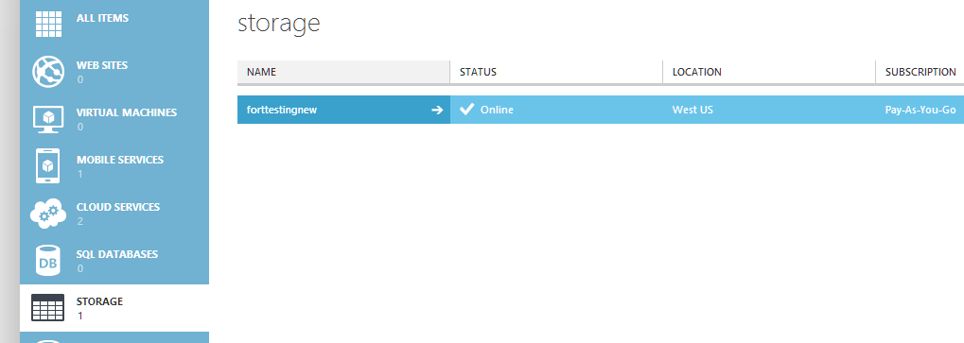

Create 2: Now Create Windows 8 App or any other App or Project.

Right click on “References” & select “Manage NuGet Packages…”

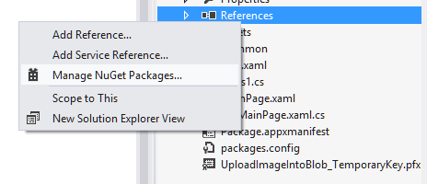

Enter the term for search “Windows Azure Storage”

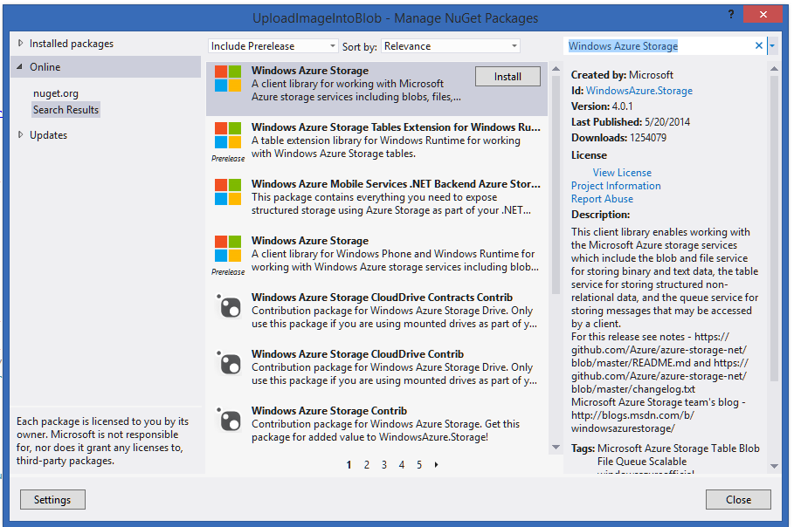

Step 3: after installation Windows Azure Storage Package or DLL added to the App.

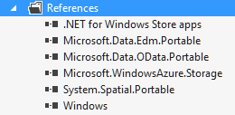

Step 4: Open MainPage.xaml.cs file

First add references

using Microsoft.WindowsAzure.Storage;

using Microsoft.WindowsAzure.Storage.Auth;

using Microsoft.WindowsAzure.Storage.Blob;

using Windows.UI.Popups;

protected override async void OnNavigatedTo(NavigationEventArgs e)

{

// Retrieve storage account from connection string

CloudStorageAccount storageAccount = new CloudStorageAccount(

new StorageCredentials("forttestingnew",

"rYxKzO5nz9h6LEKZlX2TWXtJHeuJ2d0a+3jytW9QWX6JmBcgut1g8GhFAmvfV5SiEEHdKCI0nGG1IdCSTw9UVg=="), true);

// Create the blob client

CloudBlobClient blobClient = storageAccount.CreateCloudBlobClient();

// Retrieve reference to a previously created container

CloudBlobContainer container = blobClient.GetContainerReference("mynewcontainer");

await container.CreateIfNotExistsAsync();

// Make the Container publicly visible

BlobContainerPermissions permissions = new BlobContainerPermissions();

permissions.PublicAccess = BlobContainerPublicAccessType.Blob;

await container.SetPermissionsAsync(permissions);

var msgDlg = new MessageDialog("Container Successfully Created.");

await msgDlg.ShowAsync();

}

Before run the app.

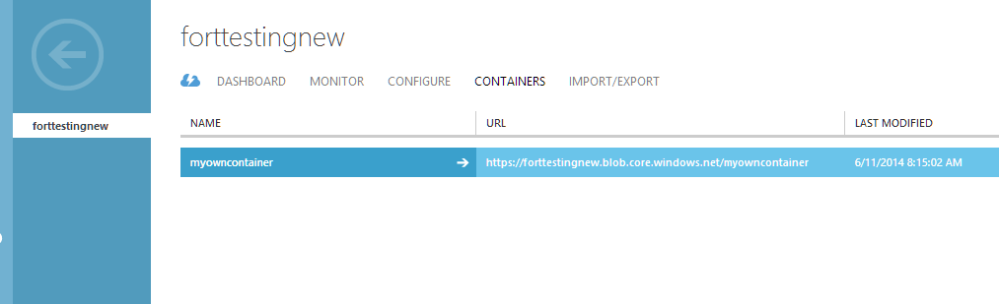

Now run the app.



Go to Windows Azure Management Portal

Open Storage

